Motion Title: Installation of Children’s Community Book Sheds in the GB2 ward of Greenham parish
Motion Proposed By: Adrian Abbs
Seconded By: Steve Allen
Purpose:
To promote literacy, community engagement, and public interaction by installing up to four Little Book Shed units in accessible locations in the newly developed David Wilson Homes site at Newbury Racecourse to serve the GB2 Ward
Motion Text:
This Council resolves to:
- Work with the Racecourse Residents Association to locate and get approval for the installation of up to four “Little Book Sheds” at key locations within GB2
- That the community engagement group collaborate with local organisations, schools, and volunteers to help maintain and stock the sheds with donated books.
- Incorporate signage and design elements that encourage public participation, foster reading, and ensure inclusivity.
- Allocate a modest budget of up to £2.5K via the Good Exchange for initial setup costs. Each shed is around £1K to £1.5K when groundworks are involve
Background:
Encouraging literacy from a young age lays the foundation for lifelong learning, curiosity, and confidence. Children who engage with books early on tend to develop stronger language skills, better comprehension, and improved focus. Reading isn’t just about decoding words—it nurtures imagination, empathy, and a sense of the world beyond their immediate surroundings.
Early exposure to storytelling also boosts cognitive development, helping children understand cause and effect, follow sequences, and express their own thoughts more clearly. These skills are essential not only in school but in everyday problem-solving and communication.
Furthermore, literacy opens doors: academically, socially, and eventually, professionally. It helps children participate fully in society, question ideas, and make informed choices. A child who reads is more likely to grow into an adult who reflects, questions, and contributes.
Creating positive reading experiences—whether through libraries, book sheds, or bedtime stories—can spark a lifelong love of learning. And in communities, fostering literacy is one of the simplest and most impactful investments we can make in a child's future.
Example shed
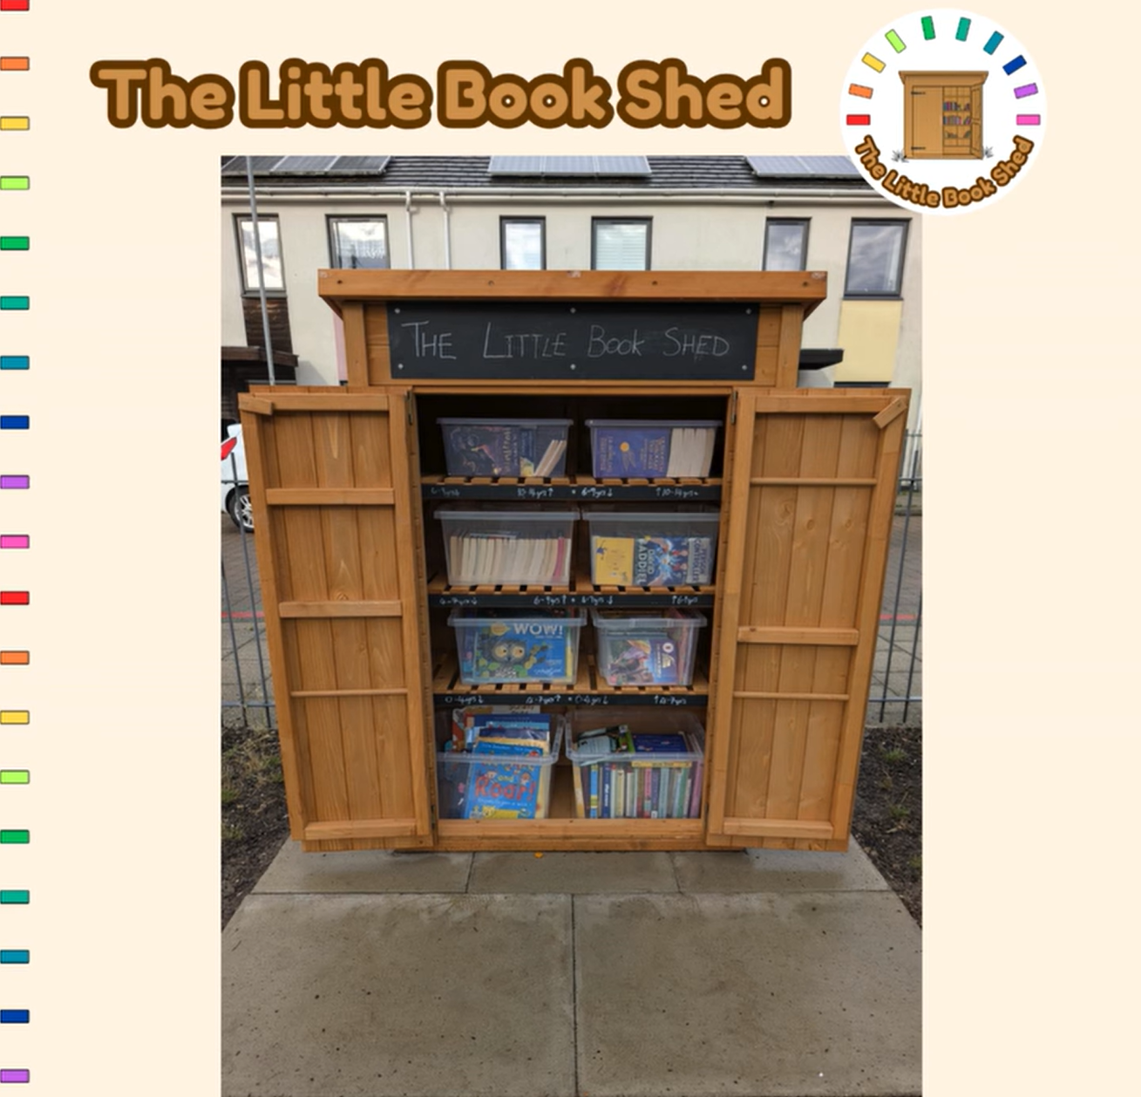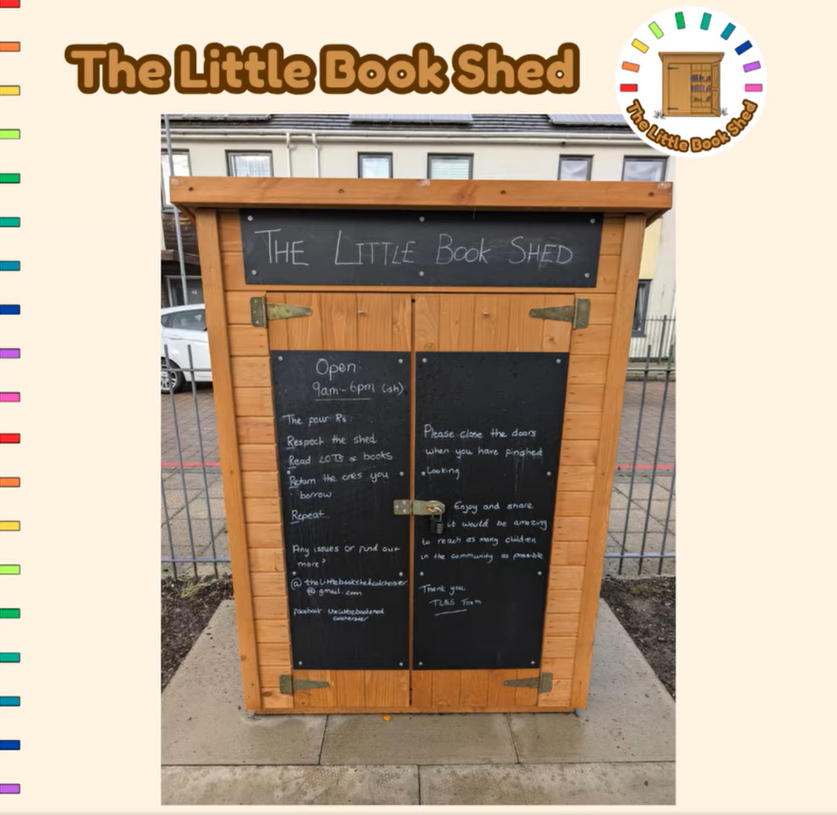
Parts Needed to be purchased
- Slabs to mount shed on
- Kist to securing the shed to strong fence
- The Shed itself
- The plastic containers for weather
Parts to be donated
- Books

